Magazin virtual

Nume participanti:

-Nan Eusebiu-Andrei(6B)

-Gruia Dumitru-Cristinel(6A)

Descriere:

Proiectul reprezintă o aplicație APEX pentru gestionarea unui magazin online de produse electronice. Utilizatorii pot vizualiza produse, comenzi, clienți și pot adăuga produse într-o comandă deja existentă. Baza de date este structurată în jurul relațiilor dintre produse, categorii, producători și comenzile clienților.

6.1:

CREATE TABLE mCategorie (

tipCat VARCHAR2(5) PRIMARY KEY,

categorie VARCHAR2(50) NOT NULL,

tva NUMBER(2) NOT NULL CHECK (tva IN (5, 9, 19))

);

CREATE TABLE mProducator (

codPr VARCHAR2(5) PRIMARY KEY,

nume VARCHAR2(50) NOT NULL,

adresa VARCHAR2(100),

tel VARCHAR2(15)

);

CREATE TABLE mProdus (

codP VARCHAR2(15) PRIMARY KEY,

tipCat VARCHAR2(5) NOT NULL,

denumire VARCHAR2(100) NOT NULL,

codPr VARCHAR2(5) NOT NULL,

stoc NUMBER(5) NOT NULL,

pret NUMBER(10,2) NOT NULL,

FOREIGN KEY (tipCat) REFERENCES mCategorie(tipCat),

FOREIGN KEY (codPr) REFERENCES mProducator(codPr)

);

CREATE TABLE mComanda (

cID VARCHAR2(10) PRIMARY KEY,

cnp NUMBER(13) NOT NULL,

nume VARCHAR2(50) NOT NULL,

data DATE NOT NULL

);

CREATE TABLE mListaCom (

cID VARCHAR2(10) NOT NULL,

poz NUMBER(3),

codP VARCHAR2(15),

buc NUMBER(5) NOT NULL,

PRIMARY KEY (cID, poz),

FOREIGN KEY (cID) REFERENCES mComanda(cID),

FOREIGN KEY (codP) REFERENCES mProdus(codP)

);

6.2:

INSERT INTO mCategorie VALUES ('tm', 'Telefoane-Mobile', 19);

INSERT INTO mCategorie VALUES ('tv', 'Televizoare', 19);

INSERT INTO mCategorie VALUES ('ac', 'Accesorii', 9);

INSERT INTO mProducator VALUES ('sg', 'Samsung', 'Iuliu Maniu nr. 7, Bucuresti', '080087267864');

INSERT INTO mProducator VALUES ('ap', 'Apple', 'Str. Siliconului nr. 1, Bucuresti', '0211234567');

INSERT INTO mProducator VALUES ('xa', 'Xiaomi', 'Bd. Tehnologiei 8, Bucuresti', '0317654321');

INSERT INTO mProducator VALUES ('ph', 'Philips', 'Str. Ledurilor nr. 10, Cluj', '0264789654');

INSERT INTO mProdus VALUES ('SM-A137FL', 'tm', 'Galaxy A13', 'sg', 54, 740.00);

INSERT INTO mProdus VALUES ('IP-13', 'tm', 'iPhone 13', 'ap', 20, 4300.00);

INSERT INTO mProdus VALUES ('XM-R10', 'ac', 'Redmi Buds', 'xa', 150, 120.00);

INSERT INTO mProdus VALUES ('PH-TV55', 'tv', 'Smart TV 55\" UHD', 'ph', 12, 2300.00);

INSERT INTO mProdus VALUES ('SM-G996B', 'tm', 'Galaxy S21+', 'sg', 30, 3850.00);

INSERT INTO mProdus VALUES ('IP-15PM', 'tm', 'iPhone 15 Pro Max', 'ap', 15, 6700.00);

INSERT INTO mProdus VALUES ('PH-SB350', 'ac', 'Soundbar 350W', 'ph', 25, 950.00);

INSERT INTO mProdus VALUES ('XM-TWS', 'ac', 'True Wireless Earbuds', 'xa', 60, 150.00);

INSERT INTO mProdus VALUES ('AP-AIRT', 'ac', 'AirTag', 'ap', 200, 180.00);

INSERT INTO mProdus VALUES ('SG-S23', 'tm', 'Galaxy S23', 'sg', 25, 4400.00);

INSERT INTO mProdus VALUES ('IP-SE3', 'tm', 'iPhone SE 2022', 'ap', 18, 2400.00);

INSERT INTO mProdus VALUES ('XA-POCOX5', 'tm', 'POCO X5', 'xa', 40, 1350.00);

INSERT INTO mComanda VALUES ('C034265', 2930518391766, 'Pop Gabriela', TO_DATE('24-04-2023','DD-MM-YYYY'));

INSERT INTO mComanda VALUES ('C034266', 2930518391767, 'Ionescu Andrei', TO_DATE('12-03-2023','DD-MM-YYYY'));

INSERT INTO mComanda VALUES ('C034267', 2930518391768, 'Marin Elena', TO_DATE('05-05-2023','DD-MM-YYYY'));

INSERT INTO mComanda VALUES ('C034268', 2930518391769, 'Dumitru Vlad', TO_DATE('17-06-2023','DD-MM-YYYY'));

INSERT INTO mComanda VALUES ('C034269', 2930518391770, 'Stoica Alina', TO_DATE('28-07-2023','DD-MM-YYYY'));

INSERT INTO mComanda VALUES ('C034270', 2930518391771, 'Radu Cristian', TO_DATE('09-08-2023','DD-MM-YYYY'));

INSERT INTO mComanda VALUES ('C034271', 2930518391772, 'Moldovan Bianca', TO_DATE('20-09-2023','DD-MM-YYYY'));

INSERT INTO mComanda VALUES ('C034272', 2930518391773, 'Tudor Mihai', TO_DATE('01-10-2023','DD-MM-YYYY'));

INSERT INTO mListaCom VALUES ('C034265', 1, 'SM-A137FL', 2);

INSERT INTO mListaCom VALUES ('C034265', 2, 'IP-13', 1);

INSERT INTO mListaCom VALUES ('C034265', 3, 'XM-R10', 2);

INSERT INTO mListaCom VALUES ('C034266', 1, 'SM-G996B', 1);

INSERT INTO mListaCom VALUES ('C034266', 2, 'XM-R10', 2);

INSERT INTO mListaCom VALUES ('C034266', 3, 'PH-TV55', 1);

INSERT INTO mListaCom VALUES ('C034267', 1, 'SM-G996B', 1);

INSERT INTO mListaCom VALUES ('C034267', 2, 'IP-15PM', 1);

INSERT INTO mListaCom VALUES ('C034267', 3, 'AP-AIRT', 1);

INSERT INTO mListaCom VALUES ('C034268', 1, 'IP-15PM', 1);

INSERT INTO mListaCom VALUES ('C034268', 2, 'XA-POCOX5', 1);

INSERT INTO mListaCom VALUES ('C034268', 3, 'PH-TV55', 1);

INSERT INTO mListaCom VALUES ('C034269', 1, 'SM-A137FL', 1);

INSERT INTO mListaCom VALUES ('C034269', 2, 'XM-R10', 2);

INSERT INTO mListaCom VALUES ('C034269', 3, 'SG-S23', 1);

INSERT INTO mListaCom VALUES ('C034270', 1, 'PH-SB350', 1);

INSERT INTO mListaCom VALUES ('C034270', 2, 'IP-13', 1);

INSERT INTO mListaCom VALUES ('C034270', 3, 'XA-POCOX5', 1);

INSERT INTO mListaCom VALUES ('C034271', 1, 'SG-S23', 1);

INSERT INTO mListaCom VALUES ('C034271', 2, 'IP-SE3', 1);

INSERT INTO mListaCom VALUES ('C034271', 3, 'XA-POCOX5', 1);

INSERT INTO mListaCom VALUES ('C034272', 1, 'PH-TV55', 1);

INSERT INTO mListaCom VALUES ('C034272', 2, 'SM-G996B', 1);

INSERT INTO mListaCom VALUES ('C034272', 3, 'IP-15PM', 1);

6.3(A) Vizualizare catalog produse

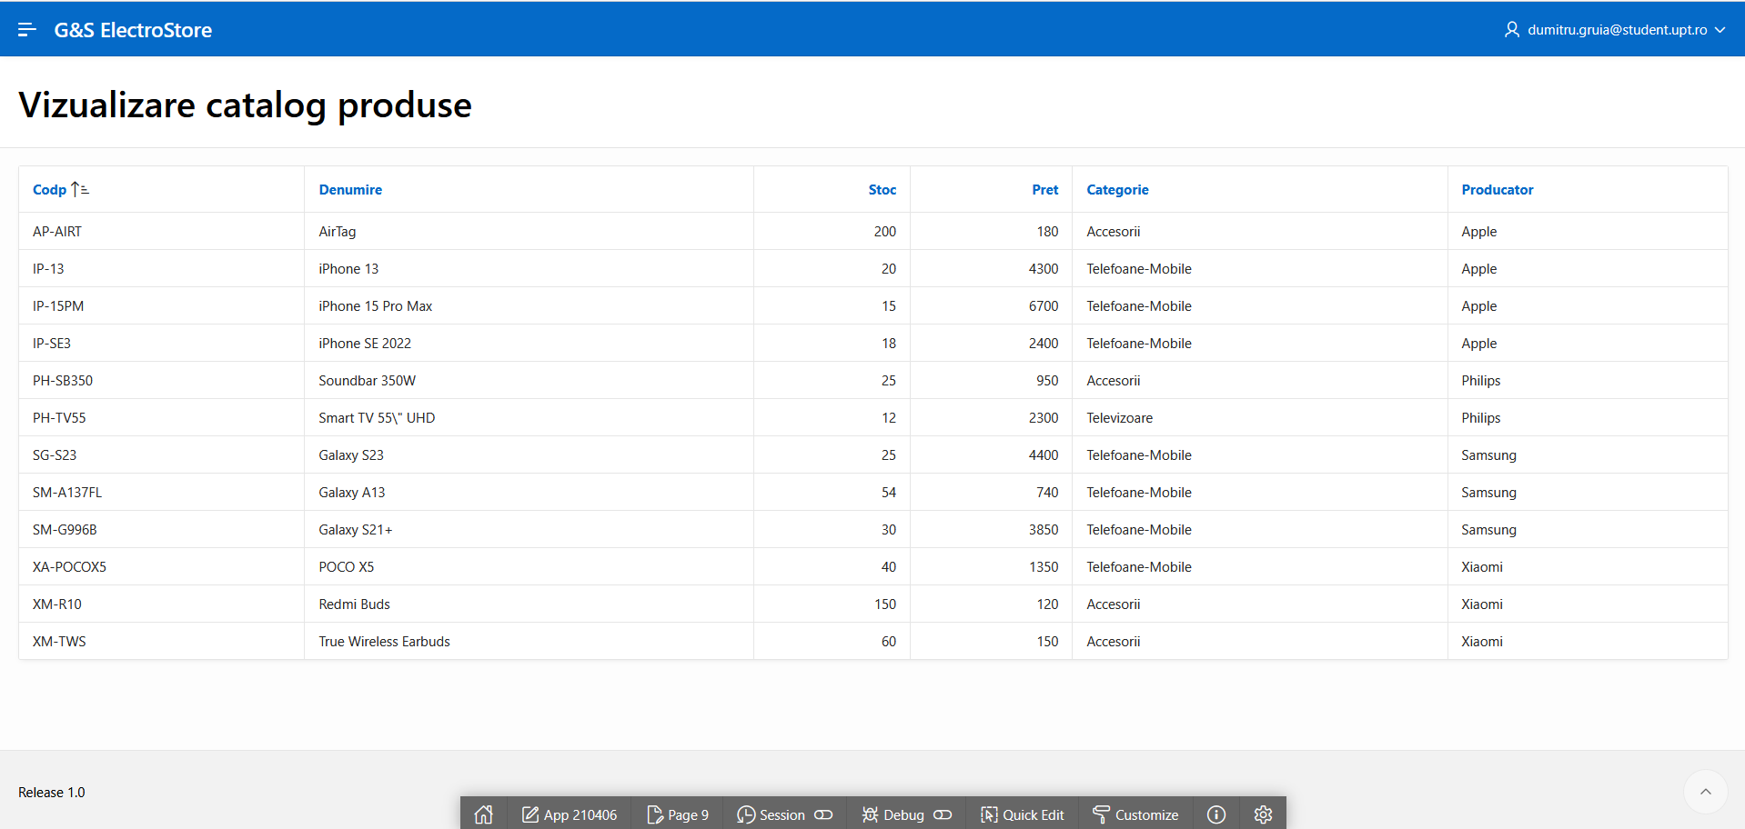Cod SQL:

SELECT p.codP, p.denumire, p.stoc, p.pret, c.categorie, pr.nume AS producator

FROM mProdus p

JOIN mCategorie c ON p.tipCat = c.tipCat

JOIN mProducator pr ON p.codPr = pr.codPr

6.4(A) Vizualizare produse pe comanda

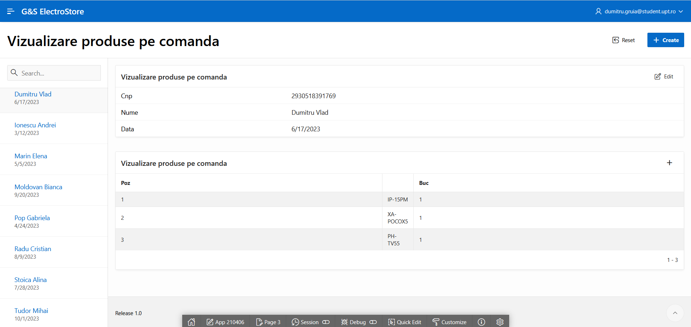

6.5(A) Vizualizare produse pentru categorie

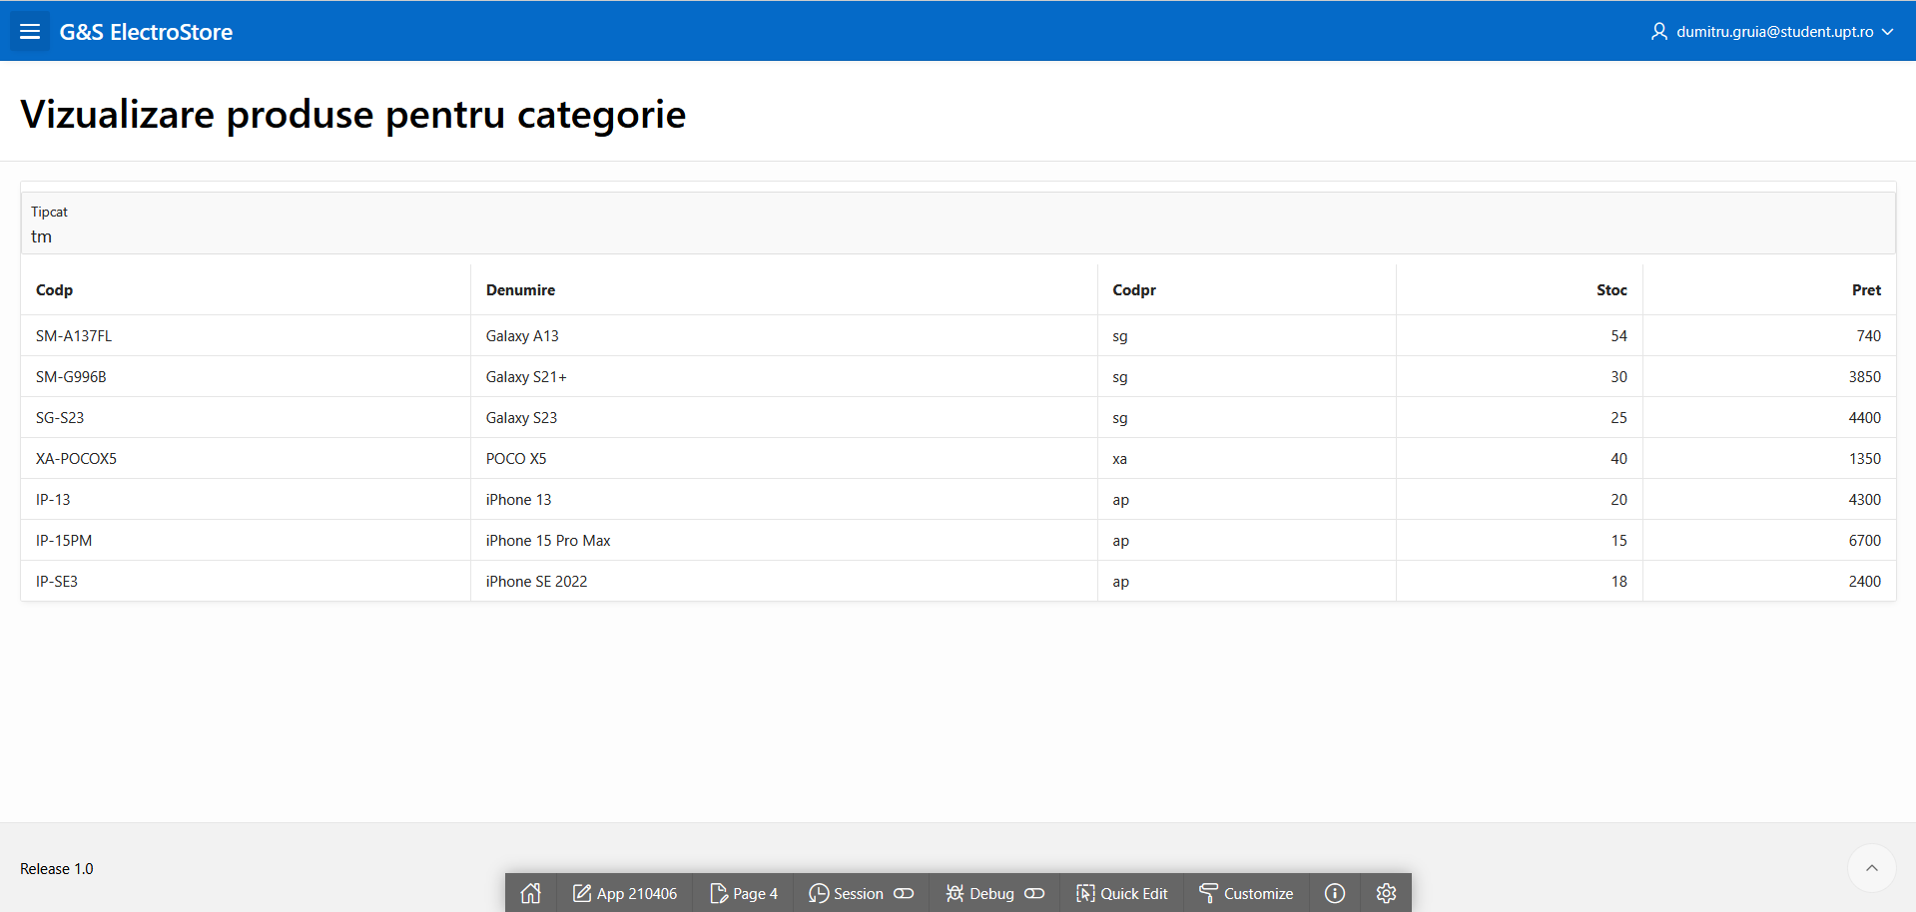

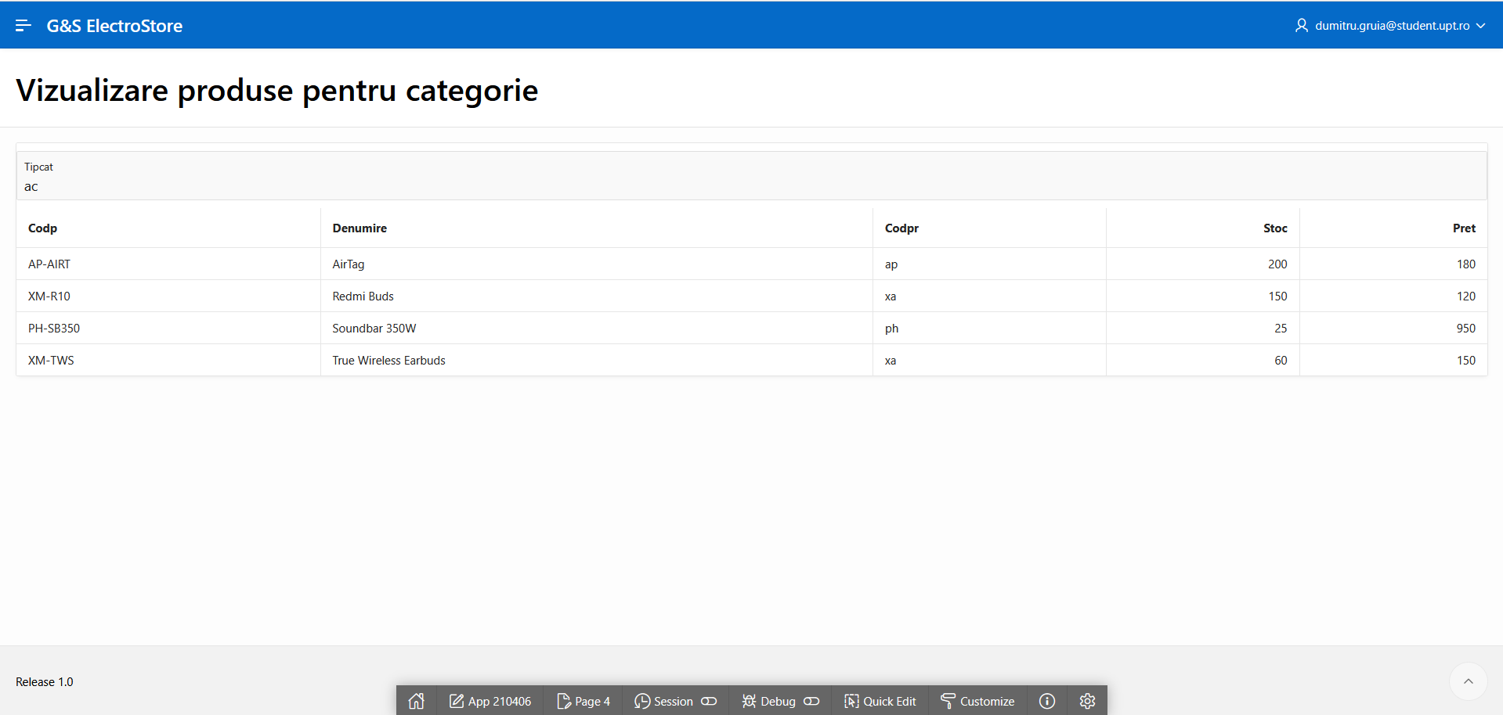

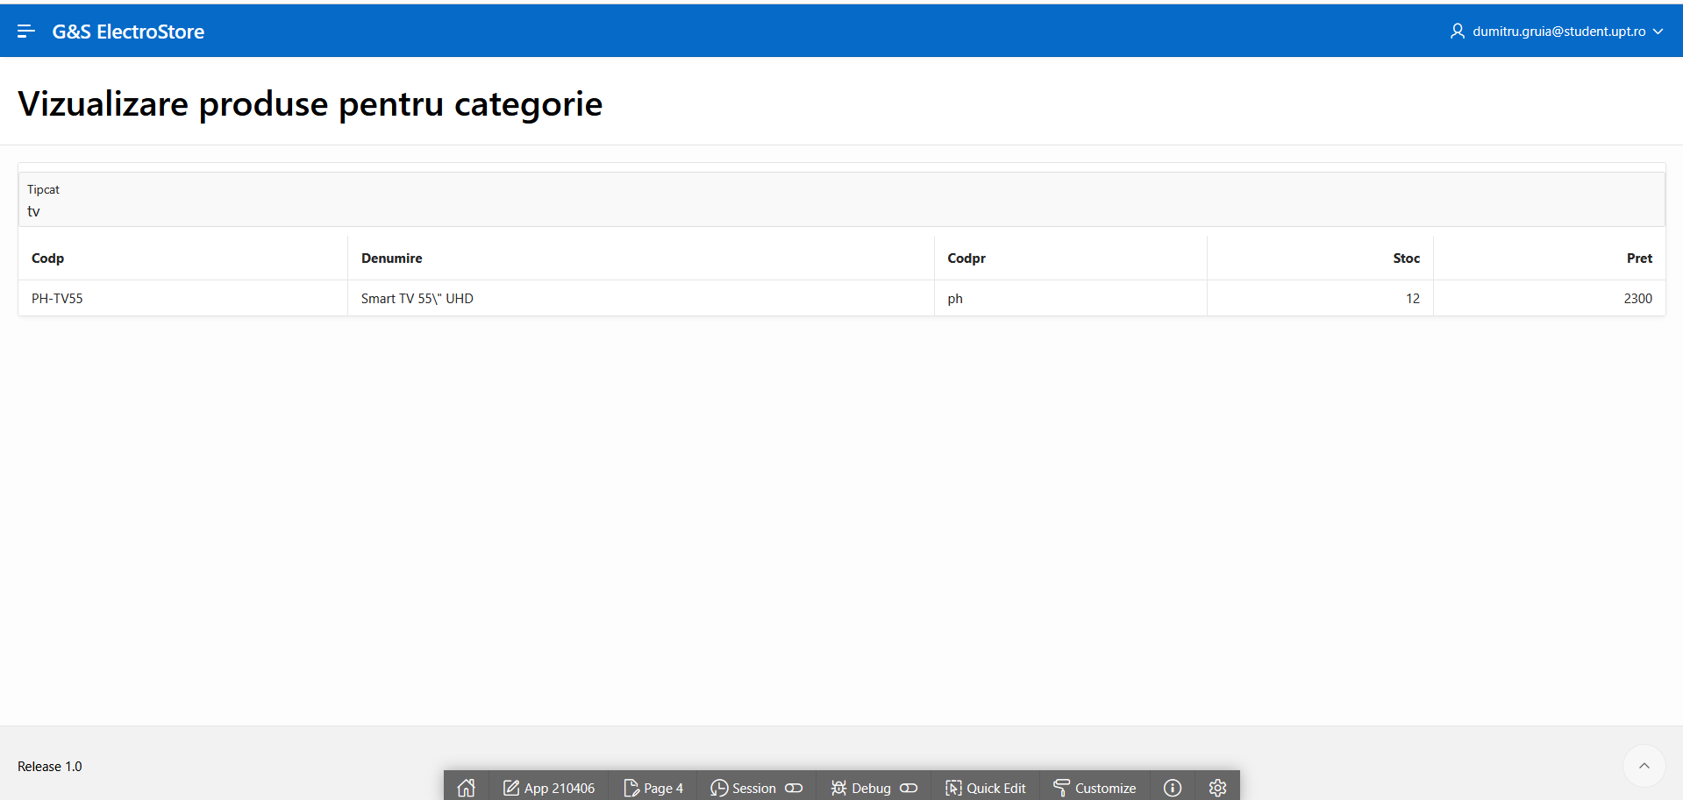

Cod SQL:

SELECT codP, denumire, codPr, stoc,pret

FROM mProdus

WHERE tipCat = :P4_TIPCAT

ORDER BY denumire

6.6(A) Raportare financiară pe categorii

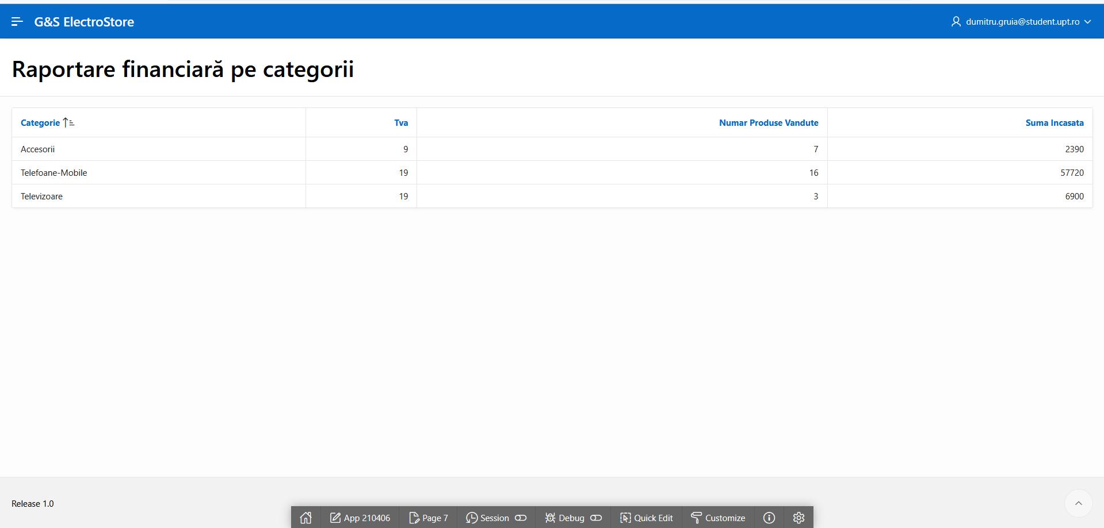

Cod SQL:

SELECT c.categorie, c.tva, COUNT(l.codP) AS numar_produse_vandute, SUM(p.pret * l.buc) AS suma_incasata

FROM mCategorie c

JOIN mProdus p ON c.tipCat = p.tipCat

JOIN mListaCom l ON p.codP = l.codP

GROUP BY c.tipCat, c.categorie, c.tva

6.3(B) Vizualizare comenzi

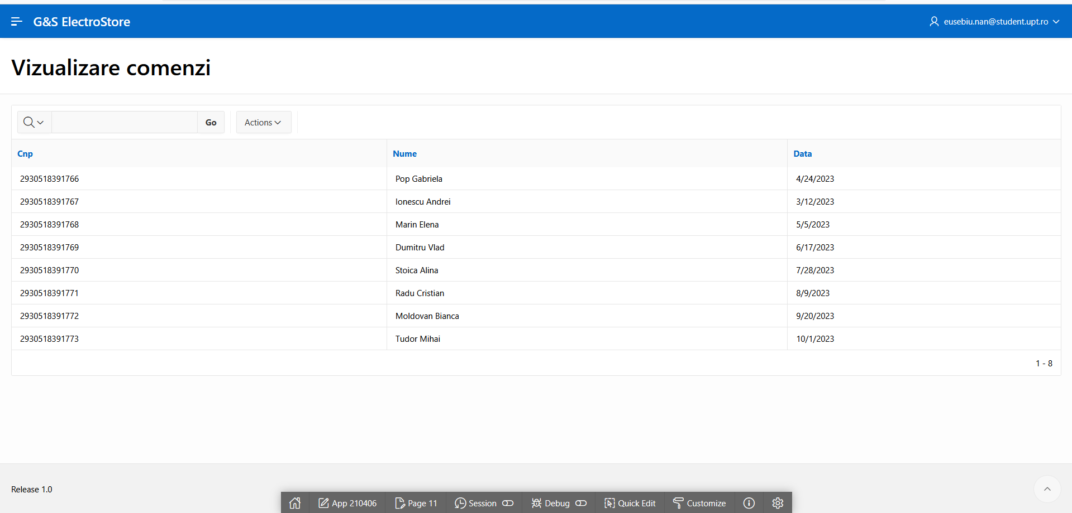

6.4(B) Adăugare produs pe comanda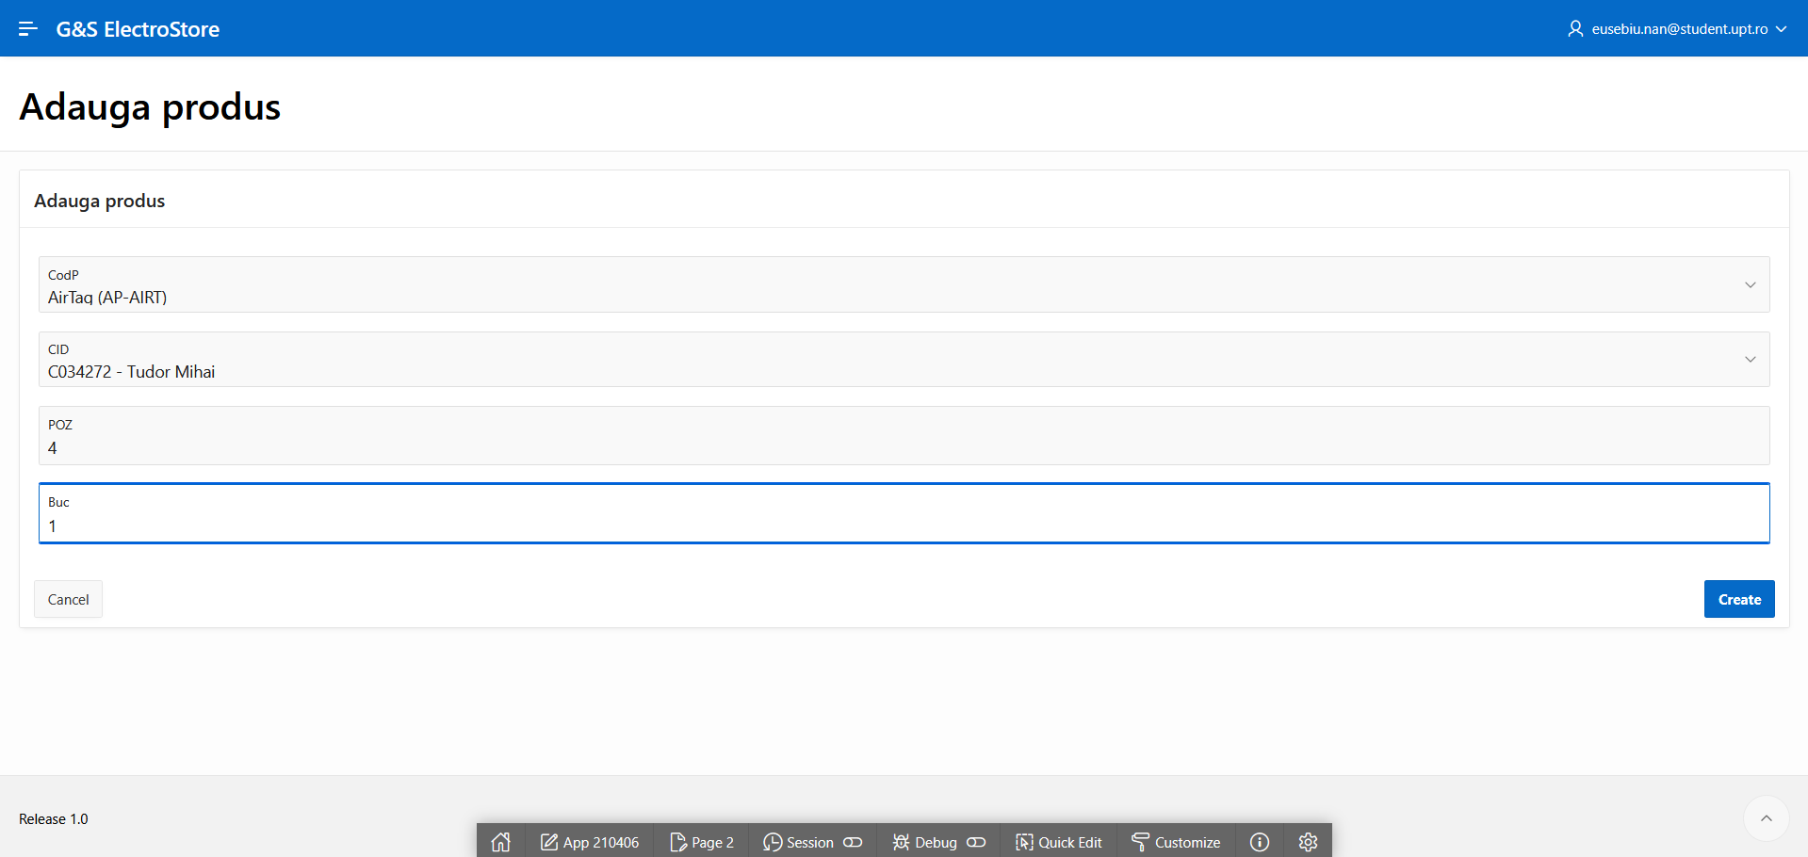Cod SQL:

SELECT denumire || ' (' || codP || ')', codP FROM mProdus ORDER BY denumire

SELECT cID || ' - ' || nume, cID FROM mComanda ORDER BY data DESC

6.5(B) Vizualizare comenzi client

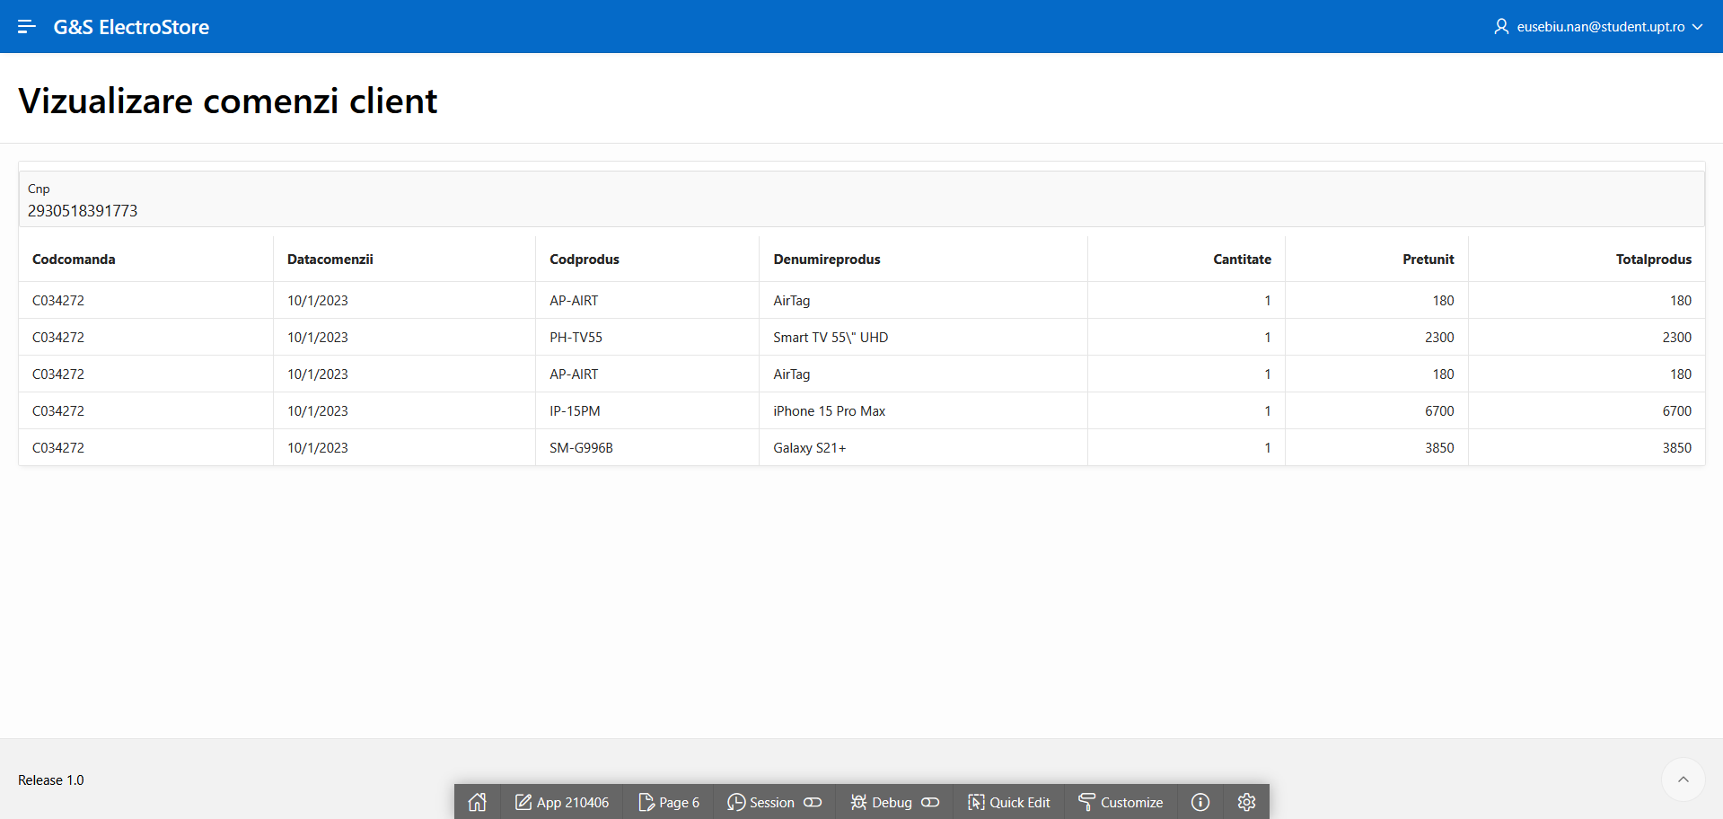(Obs:se poate observa si produsul adaugat anterior)

Cod SQL:

SELECT cm.cID AS CodComanda,

cm.data AS DataComenzii,

p.codP AS CodProdus,

p.denumire AS DenumireProdus,

l.buc AS Cantitate,

p.pret AS PretUnit,

p.pret * l.buc AS TotalProdus

FROM mComanda cm

JOIN mListaCom l ON cm.cID = l.cID

JOIN mProdus p ON l.codP = p.codP

WHERE cm.cnp = :P6_CNP

ORDER BY cm.data DESC

6.6(B) Raportare vânzări pe producători

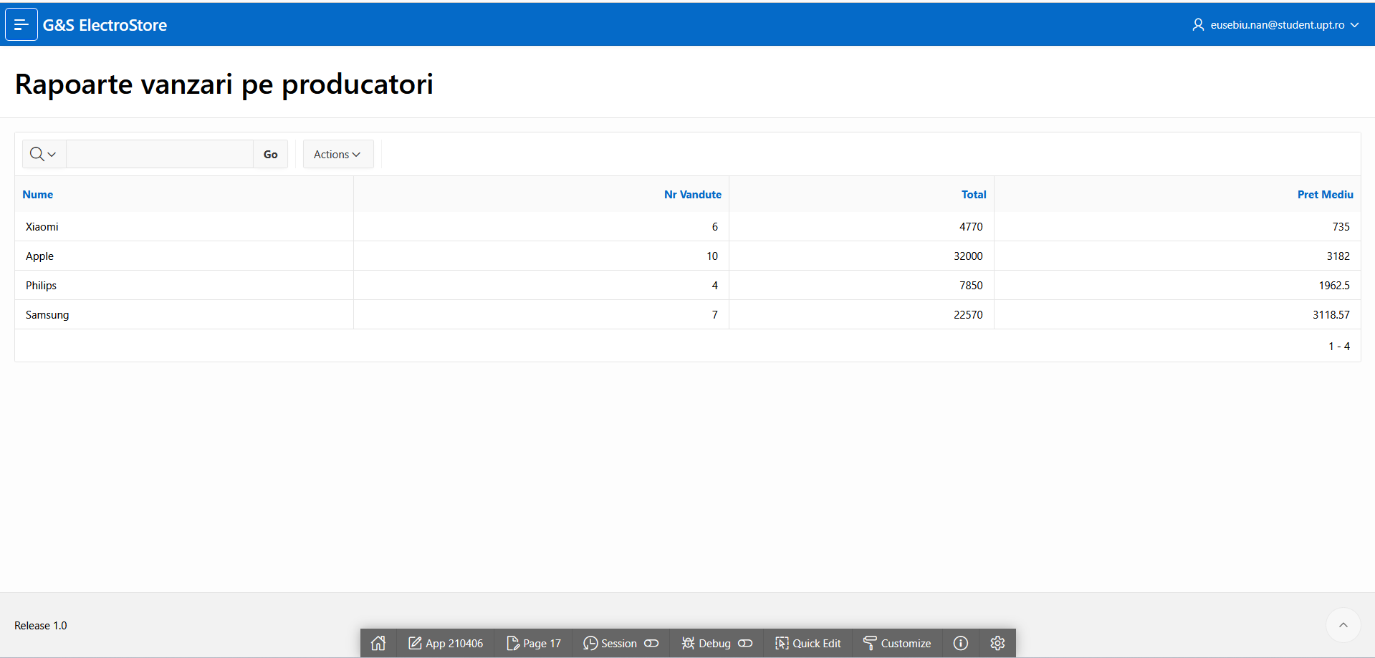

Cod SQL:

SELECT pr.nume,

COUNT(l.codP) AS nr_vandute,

SUM(p.pret * l.buc) AS total,

ROUND(AVG(p.pret), 2) AS pret_mediu

FROM mProducator pr

JOIN mProdus p ON pr.codPr = p.codPr

JOIN mListaCom l ON p.codP = l.codP

GROUP BY pr.nume

